Question: (made by Isabella)

You have 6 identical cups, which under one has a ball. You choose one cup at random to find the ball. If one cup does not have the ball, you turn it over so that you cannot choose it again and then you are equally likely to choose the ball from the remaining cups. What is the PMF of the number of trials to find the ball?

Answer:

Let X be the number of trials to find the ball. Let Bi be the event of i cups that have the ball.

px(1) = P(B1)

= 1/6

px(2) = P(B1)P(B2|B1)

= (5/6) \*(1/5)

= 1/6

px(3) = P(B1)P(B2|B1)P(B3|B2 ∩ B1)

=(5/6)\*(4/5)\*(1/4)

=1/6

Therefore each event will have a 1/6 probability considering that the ball is put into one of the six cups.

The PMF of the number of trials is then modeled by the geometric random variable:

px(b) = (1/6) \*(5/6)k-1 for k ≥ 1

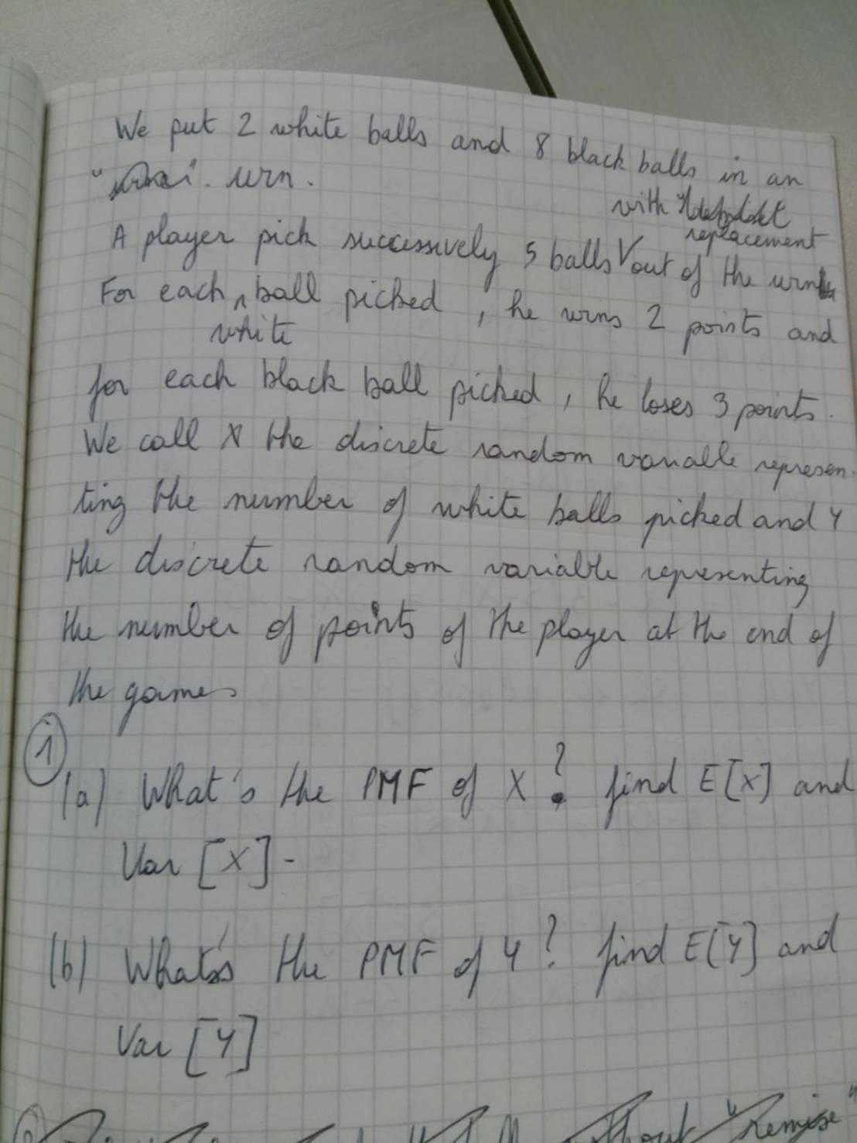

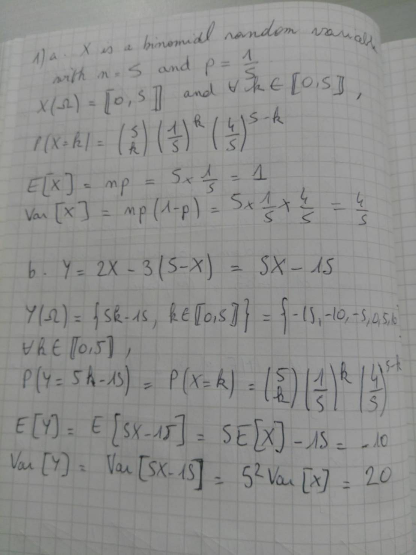

We put 2 white balls and 8 black balls in an urn. A player pick successively 5 balls with replacement out of the urn. For each white ball picked, he won 2 points and for each black ball picked, he loses 3 points. We call X the discrete random variable representing the number of white balls picked and Y the discrete random variable representing the number of points of the player at the end of the game.

1. What’s the PMF of X? Find E[X] and Var [X].
2. What’s the PMF of Y? Find E[Y] and Var[Y].